Which Package is Imported by Default in Java?

In **Java**, the **package** is the collection of Java classes and interfaces. When we use the classes of a particular **package**, we need to import that particular package in which that classes are defined. The class uses the fully qualified name that includes the package name. In most of the basic **Java programs**, we do not import any package. Here, a question arises that when we do not import any package then how Java programs allow us to use classes defined in the particular package. [**JVM**](https://www.javatpoint.com/jvm-java-virtual-machine)**internally resolve this problem by importing java.lang package by default**.

java.lang Package

**Java compiler imports java.lang package internally by default**. It provides the fundamental classes that are necessary to design a basic [Java program](https://www.javatpoint.com/java-programs). The important classes are Object, which is the root of the class hierarchy, and Class, instances of which represent classes at run time.

Let's create a [Java](https://www.javatpoint.com/java-tutorial) program that finds the number is even or odd. In this program, we have not imported any package.

**FindEvenOdd.java**

1. **public** **class** FindEvenOdd
2. {
3. **public** **static** **void** main(String args[])
4. {
5. **int** number=87;
6. //returns true if num is perfectly divisible by 2
7. **if**(number % 2 == 0)
8. System.out.println(number +" is even number.");
9. **else**
10. System.out.println(number +" is odd number.");
11. }
12. }

**Output**

87 is odd number.

Look at the above program, we have not imported any package. Nevertheless, we have used the **String** class. While we must write the fully qualified name of the class at the top of the program followed by the **import** keyword. But we have not done so. It is because Java compiler imports the **java.lang** package by default in which [String class](https://www.javatpoint.com/java-string) is defined.

If we want to check it is true or not, we can **decompile** the Java program. If you do not know how to decompile a Java program manually go through the link <https://www.javatpoint.com/java-decompiler> or use an online Java decompiler [http://www.javadecompilers.com/upload/processfile.](http://www.javadecompilers.com/upload/processfile" \t "_blank) We have decompiled the above Java program and found that **java.io.PrintStream** package imports by default. The hierarchy to import PrintStream class, as follows:

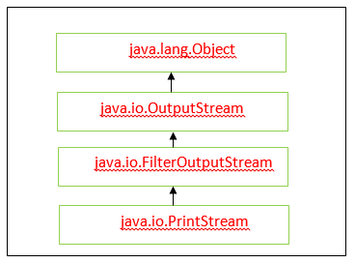

The hierarchy shows that the **Object** class of the **java.lang** package imports by default. It means the java.lang imports by default but does not show to the user.

After decompiling the above program, the program looks like the following:

1. **import** java.io.PrintStream;
2. **public** **class** FindEvenOdd
3. {
4. **public** FindEvenOdd()
5. {
6. }
7. **public** **static** **void** main(String[] paramArrayOfString)
8. {
9. **int** i = 87;
10. **if** (i % 2 == 0)
11. {
12. System.out.println(i + " is even number.");
13. }
14. **else**
15. {
16. System.out.println(i + " is odd number.");
17. }
18. }
19. }

Therefore, we need not import java.lang package explicitly. Without importing the java.lang package, we can use the classes of the package in our Java program.